
National Institute of Business Management School of Computing and Engineering
Higher National Diploma in Software Engineering HNDSE25.2F Internet of Things(IoT)
Proposal report

AI-Powered Agribot for Smart Detection of Nutrient Deficiencies in Tomato and Potato Crops Using TinyML and IoT

Submitted by
D.G.C Minidu KAHNDSE25.2F -005
J.P.K.S Lakmal KAHNDSE25.2F -014
K.P.G.M.M Rajapaksha KAHNDSE25.2F -031
G.W.D.B Weerasekara KAHNDSE25.2F -032

Submitted date.
04/09/2026
Contents
Brief Overview of the Project 3
Objectives and Expected Outcomes 3
Project Background 4
Introduction 4
Problem Domain 4
Project Aim and Objectives 5
Aim and Objectives 5
Scope and Limitations 5
Methodology / Approach 6
Steps or Phases of the Project 6
Tools, Technologies, or Software 7
Flowchart 9
Pseudocode 14
Project Deliverables 14
Expected Outputs 14
Timeline 15
Gantt Chart Placeholder 15
References 16
Appendices 17

Executive Summary

Brief Overview of the Project
Agriculture is increasingly being transformed through the integration of intelligent technologies such as Artificial Intelligence (AI) and the Internet of Things (IoT). This project proposes the design and development of an AI-powered Agribot capable of detecting nutrient deficiencies in tomato and potato crops using image-based classification and embedded machine learning techniques.
The system utilizes the ESP32-CAM as the central processing unit, enabling real-time image capture and on-device inference. A Convolutional Neural Network (CNN) is trained using Edge Impulse and deployed on the device for classification tasks.
The Agribot is equipped with a multi-tank spraying mechanism and a rotating nozzle system that enables targeted delivery of nutrients based on detected deficiencies. Additionally, environmental sensors are used to monitor plant growth conditions. Communication is achieved using MQTT, enabling real-time data transmission and monitoring.

Objectives and Expected Outcomes
Objectives:

- Develop an autonomous robotic platform for agricultural monitoring
- Implement AI-based detection of nutrient deficiencies
- Enable automated, targeted spraying using a multi-nozzle system
- Integrate environmental sensing for plant growth monitoring
- Facilitate real-time communication using MQTT

Expected Outcomes:

- Accurate classification of plant deficiencies (>80%)
- Reduced manual labor in agriculture
- Improved precision in fertilizer application
- Enhanced crop productivity and sustainability

Project Background

Introduction
Agriculture is a cornerstone of economic stability and food security in developing regions. However, inefficiencies persist due to reliance on manual inspection and generalized fertilizer application. Nutrient deficiencies—particularly nitrogen (N), phosphorus (P), and potassium (K)—significantly impact crop health, yield, and quality. Early detection is crucial but often inaccurate due to human subjectivity.
Recent advancements in embedded AI and IoT enable on-device intelligence, reducing latency and dependency on cloud infrastructure. This project proposes an autonomous Agribot that leverages TinyML for real-time leaf analysis and performs precise interventions.

Problem Domain
One of the key challenges in agriculture is the identification of nutrient deficiencies in crops. Essential nutrients such as nitrogen (N), phosphorus (P), and potassium (K) play critical roles in plant growth. Deficiencies in these nutrients can lead to:
- Reduced photosynthesis
- Poor plant development
- Decreased yield
Manual identification is often unreliable due to:
- Human error
- Lack of expertise
- Delayed detection

Motivation
The motivation for this project arises from the need to:
- Improve early detection of plant stress
- Automate corrective actions
- Reduce dependency on manual labor
- Introduce low-cost smart farming solutions

Project Aim and Objectives

Aim and Objectives
Aim

To design and implement an AI-enabled Agribot that detects nutrient deficiencies in tomato and potato leaves and performs automated, targeted spraying using a multi-nozzle system.

Objectives

- Develop a mobile robotic platform using an embedded controller
- Capture and preprocess leaf images in real time
- Train a CNN-based classification model using TinyML
- Classify conditions into: Healthy, Nitrogen, Phosphorus, Potassium, Water Stress
- Design a 4-tank spraying system with controlled actuation
- Integrate environmental sensors for growth monitoring
- Implement MQTT-based communication for telemetry and control
- Evaluate system performance (accuracy, latency, power consumption)

Scope and Limitations

Scope

- Crops: Tomato and Potato
- Conditions: 5 classes per crop (10 total)
- On-device inference using embedded hardware
- Semi-controlled field testing
Limitations

- Visual mapping of diseases to deficiency-like categories (approximation)
- Dependence on lighting conditions for image capture
- Limited model size due to embedded constraints

Methodology / Approach

Steps or Phases of the Project
Phase 1: Research & Planning
- Literature review and system design

Phase 2: Dataset Preparation
- Collect images from datasets and online sources
- Label images based on visual symptoms

Phase 3: AI Model Development
- Train CNN model using Edge Impulse
- Optimize for embedded deployment

Phase 4: Hardware Development
- Assemble robot chassis
- Integrate motors, sensors, and pumps

Phase 5: System Integration
- Combine AI model with hardware
- Implement control logic

Phase 6: Testing & Evaluation
- Evaluate accuracy and performance

Literature Review

AI in Agriculture

Recent studies demonstrate the effectiveness of deep learning models in plant disease detection. CNN-based approaches have achieved accuracy levels exceeding 90% in controlled datasets.

TinyML Applications

TinyML enables machine learning inference on low-power devices such as microcontrollers. This reduces reliance on cloud computing and enables real-time decision-making.

IoT in Smart Farming

IoT systems facilitate:

- Real-time monitoring
- Remote control
- Data-driven insights

Tools, Technologies, or Software

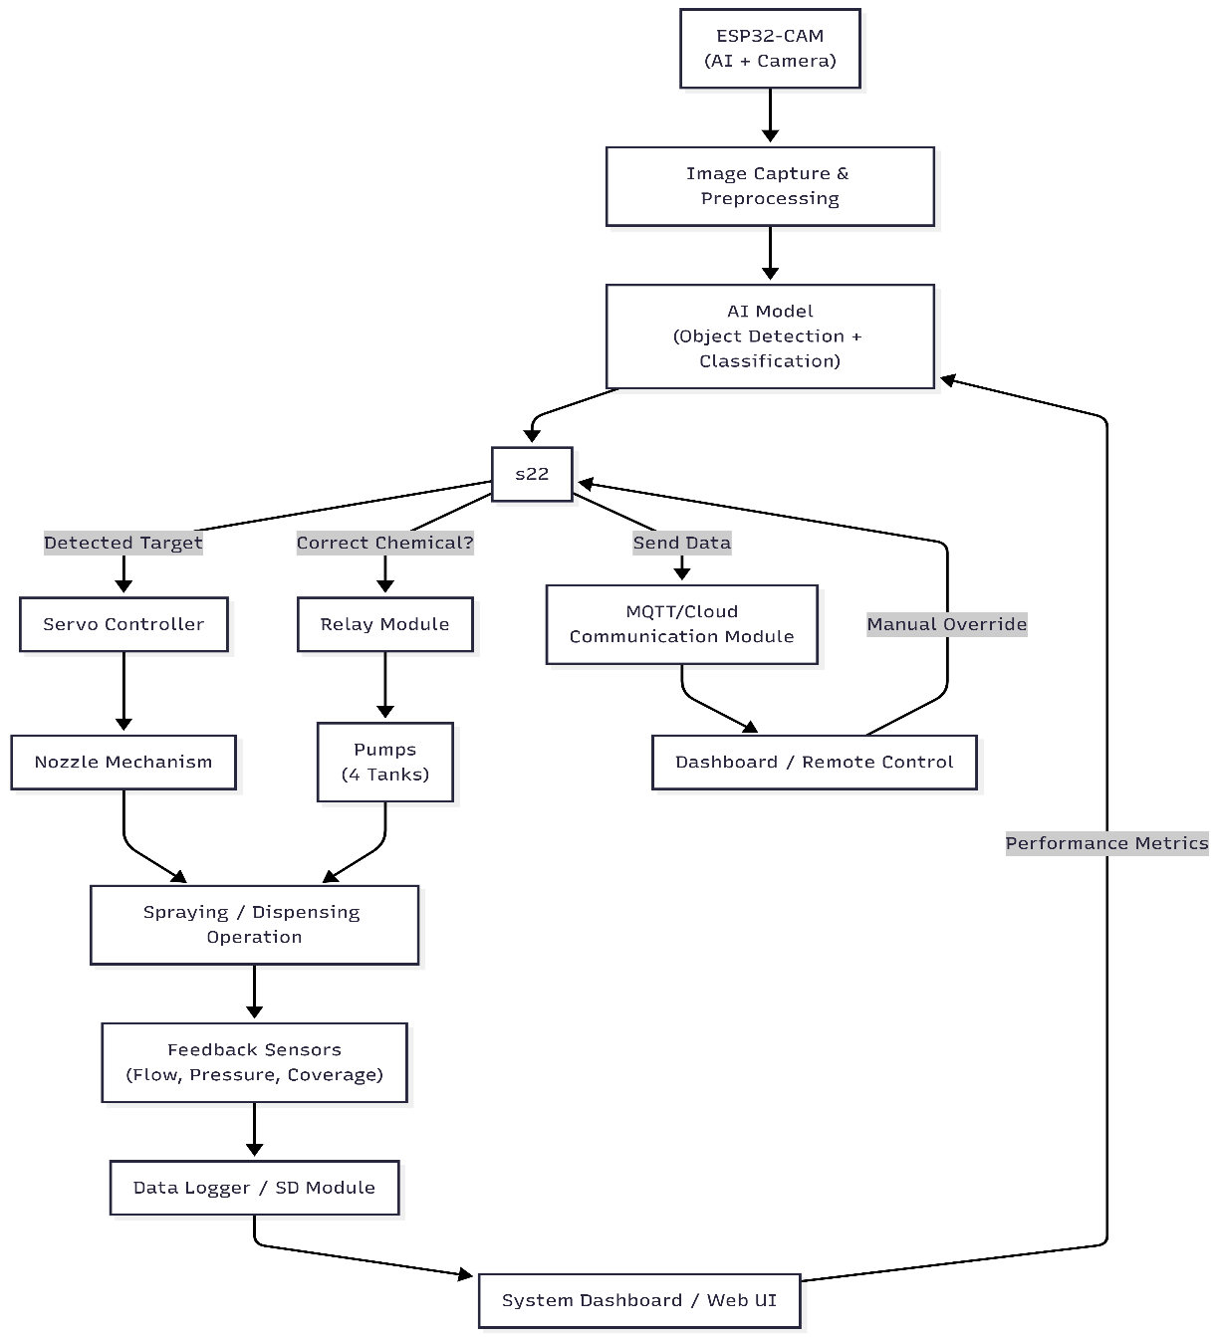
System Architecture
Component Interaction

Component | Function
ESP32-CAM | Processing + image capture
CNN Model | Classification
Sensors | Environmental monitoring
Pumps | Liquid delivery
MQTT | Communication

Methodology

Dataset Preparation

- Source: Public datasets + curated web images
- Strategy: Visual re-labeling based on symptoms
- Classes: 10 (Tomato/Potato × 5 conditions)

Table 1: Class Definitions

Class | Visual Indicator
Healthy | Uniform green
Nitrogen | Yellowing
Phosphorus | Purple tint
Potassium | Brown edges
Water Stress | Wilting/drying

Flowchart

AI-Pipeline Flow Chart

Images → Preprocessing → CNN Training → Model Export → Deployment

AI-Model Design

CNN Architecture

Input (96x96)
↓
Conv Layer
↓
MaxPooling
↓
Conv Layer
↓
Flatten
↓
Dense Layer
↓
Softmax Output

Data Preprocessing

- Resize: 96×96
- Normalize pixel values
- Remove noise and duplicates
- Augmentation: rotation, flipping, brightness variation

Model Development

Platform: Edge Impulse

Model Architecture:

- Conv2D → ReLU → MaxPool
- Conv2D → ReLU → MaxPool
- Flatten → Dense → Softmax

Training Configuration
Table 2: Training Parameters

Parameter | Value
Epochs | 30
Batch Size | 16
Split | 70/20/10
Input Size | 96×96

Deployment

- Export as Arduino library
- Upload to ESP32-CAM
- Real-time inference from camera feed

Hardware Design

Controller

- ESP32-CAM
Mobility

- 4WD chassis + DC motors
- Motor driver (L298N)
Spraying System

- 4 tanks (N, P, K, Water)
- 4 pumps
- 4-channel relay

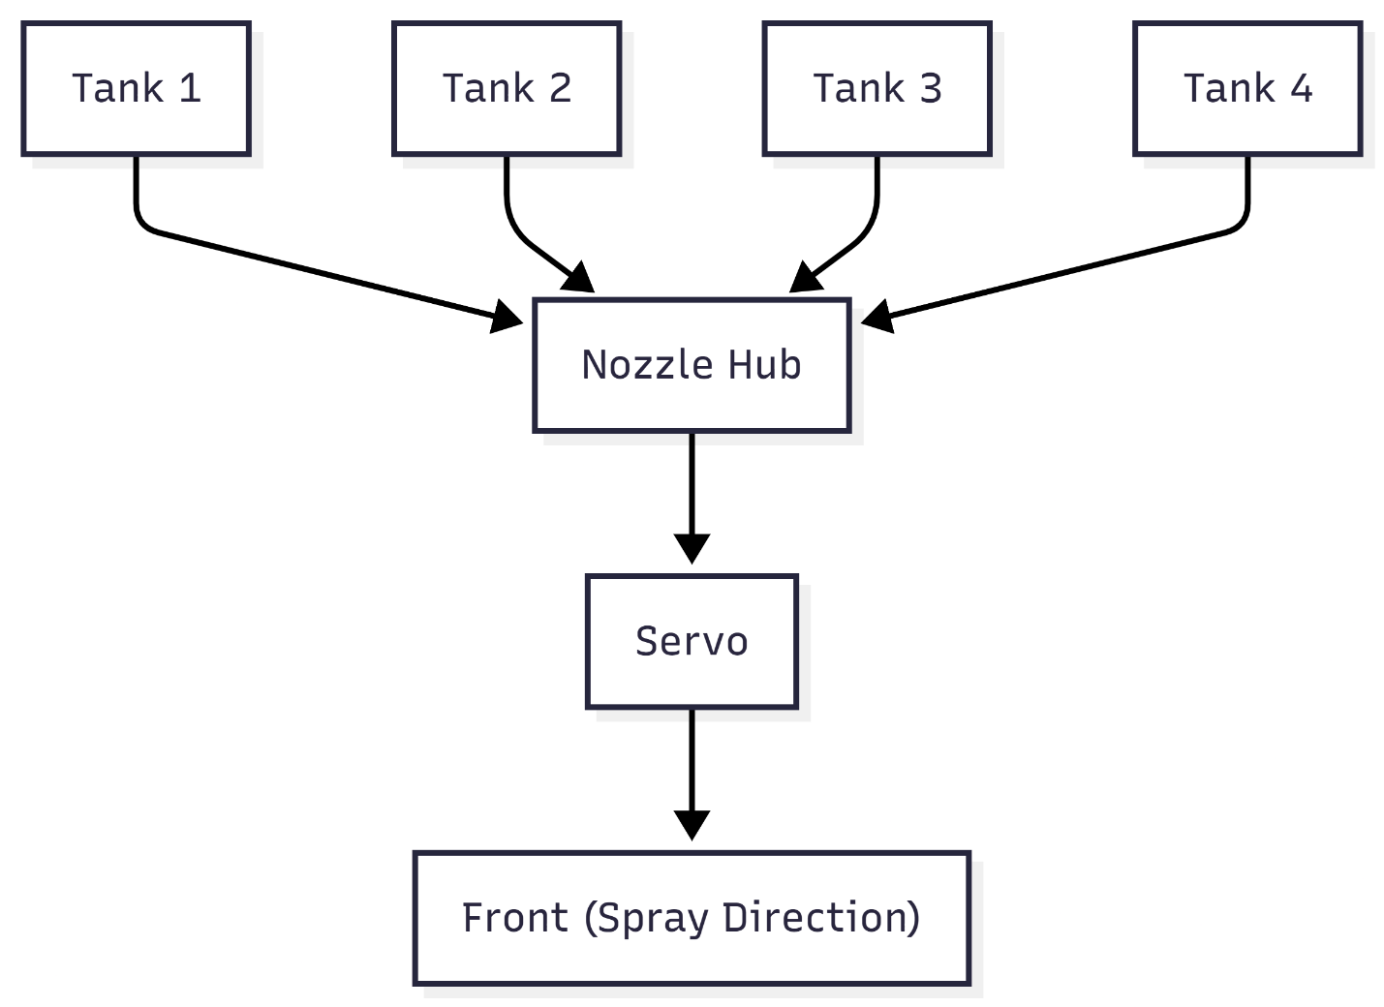

Figure 2: Mechanical Layout

Nozzle Mechanism Design

- 4 nozzles mounted on a rotating disc
- Servo enables circular motion
- Secondary servo enables vertical tilt

IoT Communication

Protocol: MQTT

Topics:
- agribot/detection
- agribot/action
- agribot/status

Growth Monitoring

Sensors:

- Soil Moisture
- Temperature/Humidity
Rule Logic:

IF moisture < threshold → Water Stress
IF temp high → Heat Stress
IF healthy + optimal → Good Growth

System Workflow

Capture → Classify → Decide → Rotate → Spray → Report (MQTT)

Testing and Evaluation

Metrics:

- Accuracy
- Latency
- Power consumption

Test Cases:

- Controlled leaf samples
- Different lighting conditions

Pseudocode

START
Capture Image
Run AI Model
IF Deficiency == Nitrogen
Activate Tank 1
ELSE IF Deficiency == Phosphorus
Activate Tank 2
ELSE IF Deficiency == Potassium
Activate Tank 3
ELSE IF Deficiency == Water Stress
Activate Tank 4
ELSE
No Action
Rotate Nozzle
Spray
Send Data via MQTT
END

Project Deliverables

Expected Outputs
Deliverable | Description
Prototype | Fully functional Agribot
AI Model | Trained CNN model
Software | Embedded system code
Report | Final project documentation
Presentation | Slides and demo

Timeline

Gantt Chart Placeholder

Week | Activity
1–2 | Research
3–4 | Data
5–6 | AI Model
7–8 | Hardware
9 | Integration
10 | Testing
11–12 | Report

Expected Results

- Accurate classification (>80%)
- Automated spraying
- Reduced labor
- Improved efficiency

Limitations

- Dataset limitations
- Lighting dependency
- Simplified deficiency mapping

Future Work

- Mobile app integration
- Cloud analytics

References
1. Edge Impulse, 2024. Edge Impulse documentation. Available at: https://docs.edgeimpulse.com (Accessed: 10 April 2026).

2. Kaggle, 2024. Plant Village dataset. Available at: https://www.kaggle.com (Accessed: 10 April 2026).

3. FAO, 2022. Global agriculture outlook. Available at: https://www.fao.org (Accessed: 10 April 2026).

4. Goodfellow, I., Bengio, Y. and Courville, A., 2016. Deep learning. Cambridge: MIT Press.

5. Russell, S. and Norvig, P., 2021. Artificial intelligence: A modern approach. 4th ed. Pearson.

6. Bishop, C.M., 2006. Pattern recognition and machine learning. Spring

Appendices

E1. Dataset Composition Summary

The dataset used for training the TinyML model consists of images collected from multiple open-source platforms and manually curated sources. The dataset was structured to ensure class balance and improve model generalization.

Class Label | Description | Number of Images
Tomato_Healthy | Healthy tomato leaves | 500
Tomato_Nitrogen | Yellowing of older leaves | 400
Tomato_Phosphorus | Purple/dark discoloration | 400
Tomato_Potassium | Leaf edge burn | 400
Potato_Healthy | Healthy potato leaves | 500
Potato_Nitrogen | Pale/yellow leaves | 400
Potato_Phosphorus | Dark/purple leaves | 400
Potato_Potassium | Brown edges/scorching | 400

Total Dataset Size: ~3400 images
To improve performance, the dataset was augmented using rotation, flipping, zooming, and brightness adjustments.

E2. Data Augmentation Parameters

To enhance the robustness of the AI model, data augmentation techniques were applied during training.
Parameter | Value
Rotation Range | ±20°
Horizontal Flip | Enabled
Vertical Flip | Enabled
Zoom Range | 0.8 – 1.2
Brightness Adjustment | ±15%
Image Resolution | 96 × 96 pixels

These transformations help the model perform well under real-world conditions such as varying lighting, camera angles, and environmental disturbances.

E3. Sensor Data Range and Threshold Values

The Agribot integrates environmental sensors to support AI-based decision-making. The following thresholds are used to assess plant health:
Parameter | Optimal Range | Deficiency Indicator
Soil Moisture | 40% – 70% | < 30% (Water deficiency)
Temperature | 20°C – 30°C | > 35°C (Stress condition)
Humidity | 50% – 80% | < 40% (Dry environment)

Sensor data is continuously monitored and transmitted to the microcontroller for processing.

E4. AI Model Configuration

The AI model is developed using TinyML principles to ensure efficient edge deployment.

Parameter | Value
Model Type | Convolutional Neural Network (CNN)
Input Size | 96 × 96 × 3
Epochs | 50
Batch Size | 16
Learning Rate | 0.001
Framework | Edge Impulse
Deployment | ESP32-CAM

The model is optimized for low power consumption and real-time inference.

E5. Expected Model Performance Metrics

The expected performance of the trained model is evaluated using standard metrics:

Metric | Expected Value
Accuracy | 85% – 92%
Precision | 83%
Recall | 80%
F1-Score | 81%

These values are based on similar studies conducted in plant disease detection using edge AI systems.

E6. Decision Logic Mapping

The system integrates AI predictions with sensor data to make decisions:

AI Output | Sensor Condition | Action
Nitrogen Deficiency | Normal moisture | Spray Nitrogen solution
Phosphorus Deficiency | Normal temperature | Spray Phosphorus solution
Potassium Deficiency | Dry soil | Spray Potassium + Water
Healthy Plant | Optimal conditions | No action

E7. Liquid Distribution System Data

The robot uses a multi-tank spraying mechanism with controlled nozzles.

Tank | Content | Flow Rate
Tank 1 | Nitrogen Solution | 10 ml/sec
Tank 2 | Phosphorus Solution | 10 ml/sec
Tank 3 | Potassium Solution | 10 ml/sec
Tank 4 | Water | 15 ml/sec

Nozzles rotate in a circular motion to ensure uniform distribution.

E8. Power Consumption Estimation

Component | Voltage | Current
ESP32-CAM | 5V | 160 mA
Servo Motor | 5V | 500 mA
Water Pump | 6V | 300 mA
Sensors | 3.3V | 50 mA

Total Estimated Consumption: ~1A
A rechargeable lithium-ion battery is recommended for portability.

E9. Growth Monitoring Indicators

The system evaluates plant growth based on visual and environmental parameters:

- Leaf color intensity
- Leaf size and spread
- Number of leaves
- Moisture consistency
- Growth rate over time

These indicators help determine whether the plant is developing normally or experiencing stress.

